**BLUETOOTH CONTROLLED**

**ROBOT CAR**

**Submitted by**

Banobir Biswas Sweet (1511168042)

CSE 323, Section: 09

**Under Supervision of**

Dr. Saeed Mahmud Ullah (SMU1)



**Department of Computer Science and Engineering**

North South University

**Acknowledgement**

We have taken efforts in this project. However, it would not have been possible without the kind support and help of many individuals. We would like to extend my sincere thanks to all of them.

We are highly indebted to our project supervisor, Dr. Saeed Mahmud Ullah, for his guidance and constant supervision, for providing necessary information regarding the project. His support proving instrumental for us and we hope we can complete this project under his guidance. Thanks to North South University ECE department for providing us with this course and making a scope for us to take this project in our hand.

My thanks and appreciations also go to my colleague in developing the project and people who have willingly helped me out with their abilities.

**Table of Contents**

**Contents**

**1. Introduction** ....................................................................................................................4

**2. Objective** ....................................................................................................4

**3. Design Review** ………………………………………………………………………………………..4

Hardware……………………………………………………………………………………………….4

Software………………………………………………………………………………………………...5

**4. Equipment** ………………………………………………………………………………………………5

**5. Implementation and Testing** …………………………………………………………………..6

Arduino Codes ………………………………………………………………………………...………6

**6. Result and Discussion** ……………………………………………………………………………..8

**7. Conclusion** ………………………………………………………………………………………….……8

**1. Introduction**

This project is about building a robot car which is controlled by Android app via Bluetooth technology. The robot car is able to move forward, back, left and right. When the operator gives instruction from Android app, the instruction is received from the car and then executes.

**2. Objective**

When operator push forward button on his/her android phone in the corresponding app, the robot car will move forward. Back button for back direction, Left button for left direction and Right button for right direction. Main objective is to show that some instructions are executing properly in hardware.

**3. Design Overview**

* **Hardware:** We used some solid and basic hardware to build the robot cars body. There is two controlled primary wheels and one automated 360 degree secondary wheel. There’s three electric module – a Bluetooth module, a microcontroller and a motor controller as well as wires.

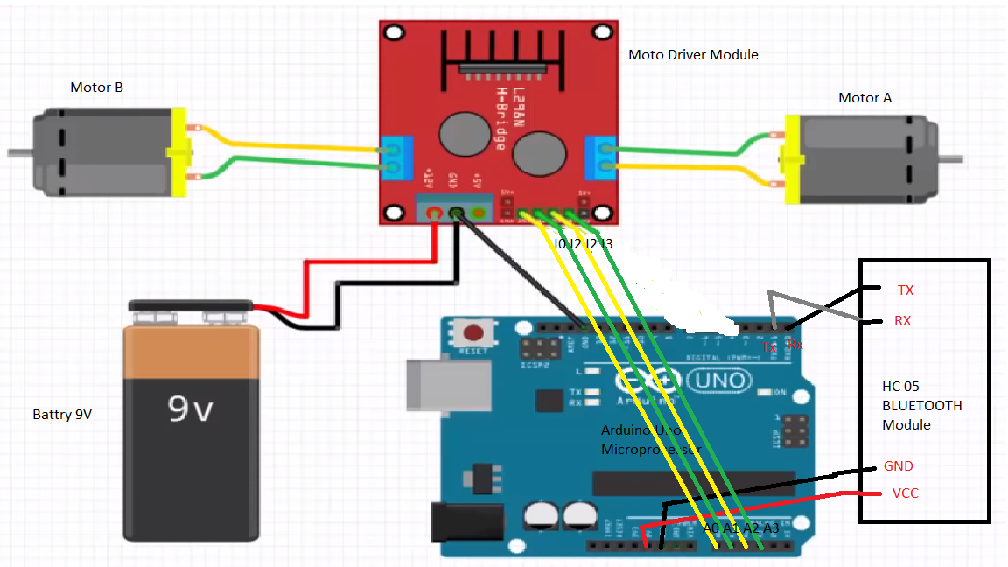

* **Software:** To build the corresponding Android app, we use MIT app inventor. We put the Bluetooth connector interface, device finder, and direction button for the app. There’s also a button for quit the connection.

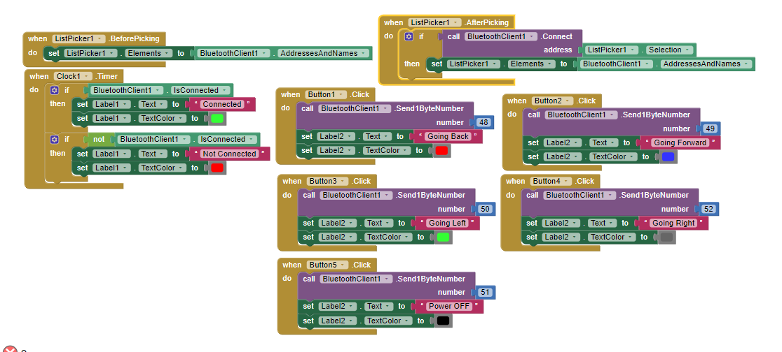

**4. Equipment**

1. Robot car chassis set (2 wheel)
2. An Android app
3. L298N Dual Motor Controller Module
4. Arduino UNO R3 Microprocessor
5. HC-05 Bluetooth to Serial Port Module (Bluetooth Module)
6. 9v rechargeable battery
7. Wires

**5. Implementation and Testing**

First of all, we needed to upload the instructions in microprocessor module. So, we wrote the valid codes and uploaded in the microprocessor module (Arduino UNO). Then we assembled the hardware on the cars chassis and connect all the modules with wires. After that, we built the Android app, then installed it on our smartphone.

Finishing all the procedures mentioned above we finally approached to the test. We connected the batteries and open the Android app. We established the connection and gave moving instructions from the app.

**Arduino Codes:**

# define mABlack A0

#define mARed A1

#define mBOrange A2

#define mBYellow A3

#define mASpeed A4

#define mBSpeed A5

int state = 0;

void setup()

{

pinMode(mABlack, OUTPUT);

digitalWrite(mABlack, LOW);

pinMode(mARed, OUTPUT);

digitalWrite(mARed, LOW);

pinMode(mBOrange, OUTPUT);

digitalWrite(mBOrange, LOW);

pinMode(mBYellow, OUTPUT);

digitalWrite(mBYellow, LOW);

pinMode(mASpeed, 0);

digitalWrite(mBSpeed, 0);

Serial.begin(9600); // Default communication rate of the Bluetooth module

}

void loop()

{

if(Serial.available() > 0){ // Checks whether data is comming from the serial port

state = Serial.read(); // Reads the data from the serial port

}

switch(state)

{

case '0' :

digitalWrite(mABlack , HIGH);

digitalWrite(mARed , LOW);

digitalWrite(mBOrange , HIGH); // 1010

digitalWrite(mBYellow , LOW);

analogWrite(mASpeed, 255);

analogWrite(mBSpeed, 255);

break;

case '1' :

digitalWrite(mABlack , LOW);

digitalWrite(mARed , HIGH);

digitalWrite(mBOrange , LOW);

digitalWrite(mBYellow , HIGH); // 0101

analogWrite(mASpeed, 255);

analogWrite(mBSpeed, 255);

break;

case '2' :

digitalWrite(mABlack , LOW);

digitalWrite(mARed , HIGH);

digitalWrite(mBOrange , LOW); // 0010

digitalWrite(mBYellow , LOW);

analogWrite(mASpeed,255);

analogWrite(mBSpeed, 255);

break;

case '3' :

digitalWrite(mABlack , LOW);

digitalWrite(mARed , LOW);

digitalWrite(mBOrange , LOW);

digitalWrite(mBYellow , LOW); //0000

analogWrite(mASpeed, 255);

analogWrite(mBSpeed, 255);

break;

case '4' :

digitalWrite(mABlack , LOW);

digitalWrite(mARed , LOW);

digitalWrite(mBOrange , HIGH); // 0010

digitalWrite(mBYellow , LOW);

analogWrite(mASpeed,255);

analogWrite(mBSpeed, 255);

break; }}

**6. Result and Discussion**

After implementing hardware and software we were successful to build the whole project. From initial test we found that there was a problem with battery, the voltage was low. So, we replaced the battery with new one. Then the hardware were executing the instructions successfully and the robot car was moving to programmed direction. So, our project is successful.

**7. Conclusion**

Doing this project was amazing. It enriched our knowledge about operating system. We learned how instructions are executed it hardware. We got the basic ideas about how hardware and software work together in a system. We can use this knowledge in future for broader plan.